
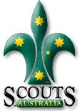
Rosanna Cubs – Greensborough RSL Monday 18th June

On Monday, the 18th, we’re going to meet at Greensborough RSL to learn about “Their Service – Our Heritage” as part of earning the Heritage Badge. Note… NO CUBS on Tuesday the 19th!

Details:
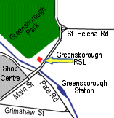
- Meet at Greensborough RSL, 111 Main St, Greensborough (see map) at
7:25pm. Pickup from the RSL at the conclusion at 8:15pm.
Cubs will be learning about the service of our Service men and women….. and if we’re lucky, they might even feed us! For those who attended Anzac Day Services, this will complete their Heritage Badge requirements. For others, this will cover half the badge and we can sort out the requirements for the rest.
Melway Ref: 20 K1

See you there – don’t miss it!

Regards

Akela & Chil
9434 7594
0411 121 495
akela@rosannacubs.org

See us at http://www.rosannacubs.org

